Science  Forces  To learn about gravity  To identify the effects of air resistance, water resistance and friction  To recognise mechanisms such as pulleys, levers and gears  Earth & Space  To describe the movement of the Earth in relation to the Sun  To describe the movement of the moon in relation to the Earth  To recognise the Earth, Sun and moon as approximately spherical bodies  To explain night and day as the movement of the Sun across the sky | Music  South and West Africa  - Sing using the correct pronunciation and with increasing confidence.  - Play a chord with two notes, remaining in time.  - Maintain their part in a performance with accuracy.  - Play the more complicated rhythms in time and with rests.  - Play more complicated rhythms in time with rests.  - Create an eight beat break and play this in the correct place.  Compositions for the festival of colour  - Suggest a colour to match to a piece of music.  - Create a graphic score and describe how this matches the general structure of a piece of music.  - Create a vocal composition in response to a picture and justify their choices using musical terms.  - Create a vocal composition in response to a colour.  - Record their compositions in written form.  - Work as a group to perform a piece of music. | Spanish  Sports in Spanish / Spanish Food and drink  - Using verbs for questions about sport.  - Recognise / use imperative verbs for game instructions.  - Translate written instructions for the Maya ball game.  - Use instructions and motivational language when playing the Maya ball game.  - Identify and classify keywords from instructions for games.  - Create written instructions for a ball game.  - Express likes and dislikes about food.  - Ask / answer questions about food preferences.  - Listen and identify food preferences.  - Deduce a person’s pizza choice by their food preferences.  - Conduct an interview about food preferences.  - Ask questions to find out food preferences.
History  Benin  - Locate Benin and understand historical chronology  - Learn about religious beliefs  - Recognise significant achievements  - To understand trade links  - Understand why the civilisation came to an end | Brackenwood Junior School    Y5  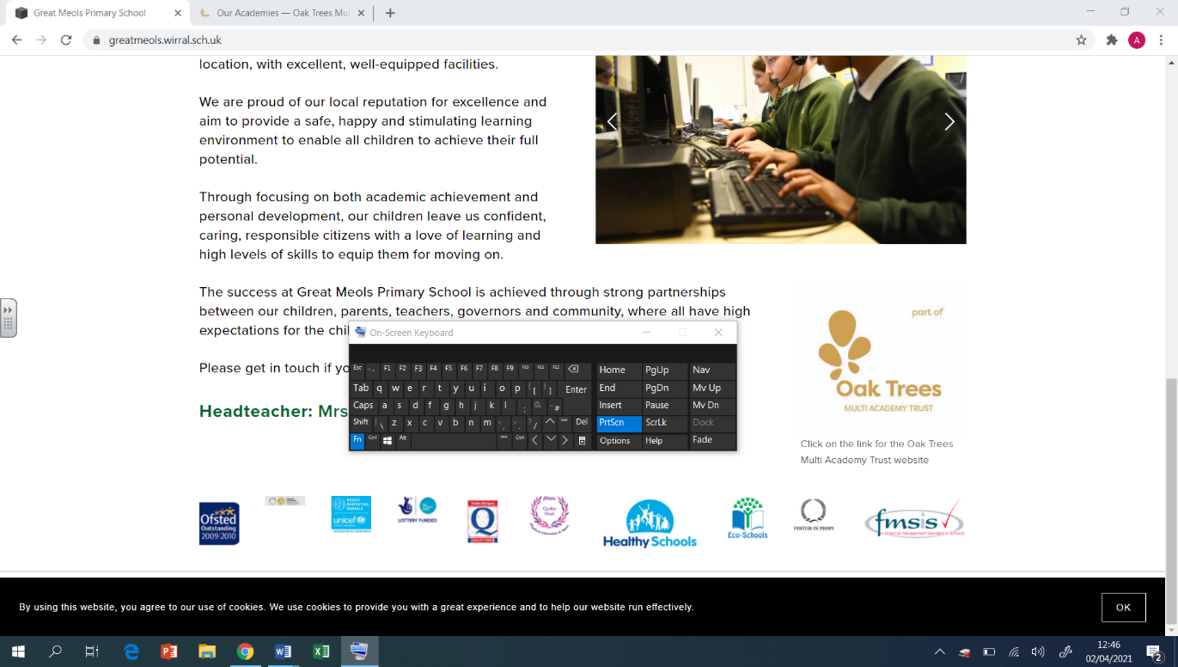  Spring Overview | PE  - Athletics  - Run and throw with greater control, accuracy and efficiency  - Health Related Fitness  Show a desire to improve previous performances  - Tennis  - Work with a teammate to apply a plan  - Basketballs  - How to manipulate and manoeuvre a basketball within the rules
Geography  - I understand what a biome is and can identify different biomes on a world map  - I understand longitude and latitude and how location impacts biomes  - I understand the layers of a rainforest  - I understand how the climate of the Amazon Rainforest impacts its biodiversity  - I understand the water cycle and how water moves around the world  - I can compare two temperatures either side of the Equator (line graph) | DT  Mechanical Systems: Pop-up Book  - To design a pop-up book.  - To follow a design brief to make a pop-up book.  - To use layers and spacers to cover the working of mechanisms.  - To create a high-quality product suitable for a target user.  Digital World: Monitoring Devices  - To carry out research to develop design criteria.  - To write a program to monitor the ambient temperature, including an alert.  - To generate creative and unique Micro:bit case, stand or housing ideas.  - To learn about and practise 3D CAD skills. | RE  Faith in Action  - Understanding that faith can mean needing to do the right thing, even if that means facing consequences  - Listening to the lyrics and faith that Stormzy puts in his music  - Understanding why Corrie Ten Boom would hide Jewish people during WW2  - How changing his name and religion impacted Muhammed Ali -looking at organisation that combine faith and charity  Christianity – Journey to the cross  - Understand the significance of the Last Supper  - knowing about a fair trial and questioning if Jesus was given a fair trial  - Look at the actions of Judas and the significance of his betrayal
Computing  Programming - Selection in Physical Computing  - To control a simple circuit connected to a computer  - To write a program that includes count-controlled loops  - To explain that a loop can stop when a condition is met  - To explain that a loop can be used to repeatedly check whether a condition has been met  - To design a physical project that includes selection  - To create a program that controls a physical computing project  Data and information – Flat-file databases  - I can explain how information can be recorded  - I can explain what a field and a record is in a database  - I can group information using a database  - I can outline how ‘AND’ and ‘OR’ can be used to refine data selection  - I can explain the benefits of using a computer to create charts  - I can present my findings to a group | Art  Painting:  • Create a colour palette based upon colours observed in the natural or built world.  • Use the qualities of watercolour and acrylic paints to create visually interesting pieces.  • Combine colours, tones and tints to enhance the mood of a piece.  • Use brush techniques and the qualities of paint to create texture.  • Develop a personal style of painting, drawing upon ideas from other artists. | PSHE  Safety and the Changing Body  - Developing an understanding of how to ensure relationships online are safe.  - Learning to make ‘for’ and ‘against’ arguments to help with decision making.  - Learning about the emotional changes during puberty.  - Identifying reliable sources of help with puberty.  - Learning about how to help someone who is bleeding.  Citizenship  - Developing an understanding about the reliability of online information.  - Exploring online relationships including dealing with problems.  - Discussing the reasons why adults may or may not drink alcohol.  - Discussing problems which might be encountered during puberty and using knowledge to help.  - Learning how to help someone who is choking.  - Placing an unresponsive patient into the recovery position.

