Science  Plants  - To identify and describe the functions of different parts of flowering plants  - To explore what a plant needs in order to survive  - To investigate how water is transported in plants  - To explore the part that flowers play in the lifecycle of flowering plants, including pollination, seed dispersal and seed formation | Music  Developing singing technique: Theme Vikings  - Move and sing as a team, following the lyrics on the screen.  - Recognise minims, crotchets and quavers often by ear and reliably by sight.  - Perform rhythms accurately from notation and layer them to create composition.  - Add appropriate sound effects to their performances using untuned percussion.  - Join in with the performances confidently, and reasonably in time and tune.  - Make suggestions for improving their performances.  Pentatonic melodies and compositions  - Match their movements to the music, explaining why they chose these movements.  - Accurately notate and play a pentatonic melody.  - Play their part in a composition confidently.  - Work as a group to perform a piece of music. | Spanish  Daily Life - Shapes and Colours in Spanish  - Recognise and name some colours in Spanish.  - Begin to describe shapes using colour adjectives.  - Create and practise descriptive phrases orally.  - Read and recognise descriptive phrases in Spanish.  - Write a design brief using shape and colour vocabulary. Create a short presentation using descriptive phrases.  Classroom Objects in Spanish  - Recognise and respond to spoken classroom instructions.  - Name school bag objects and identify if they are masculine or feminine nouns.  - Identify how a noun phrase changes in the plural form
History  Romans  - Recognise the where and when the Romans ruled  - Understanding daily life  - The Roman invasion of Britain and the lasting impact  - The significance of Boudicca  - The power/strength of the Roman army | Brackenwood Junior School    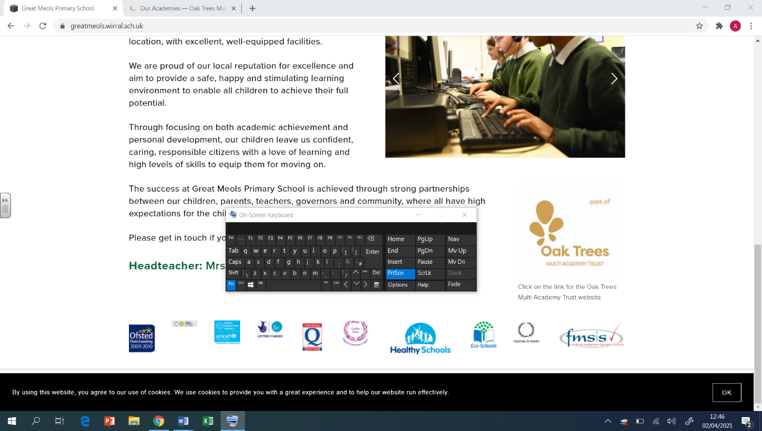  Y3  Spring Overview | PE  Athletics  - Athletics  Use running, jumping, throwing and catching in isolation and in combination  - Yoga  Retain focus and control breathing  - Tennis  Striking the ball on the forehand and backhand striking the ball downward  - Golf  To understand that a golf club must strike underneath the ball to cause elevation.
Geography  - To explain what climate means and how climates differ in different parts of the world  - To understand the key features of deserts and locate deserts around the world.  - To study of the Atacama Desert (South America study) and compare this to our own locality  - To know what animals live in the Atacama Desert (South America study)  - To know what vegetation grows in the Atacama Desert (South America study) | DT  Digital World: Wearable Technology  - To develop design criteria  - To use code to program and control a product.  - To develop and communicate ideas  - To develop ideas through Computer-aided design.  Mechanical Systems: Pneumatic Toys  - To design a toy that uses a pneumatic system.  - To create a pneumatic system  - To test and finalise ideas against design criteria. | RE  Sikhism  - how Sikhism began  - the importance of Guru Nanak to Sikhs  - the 5Ks and their significance  - why the Guru Granth Sahib is so important to Sikhs  - to understand the Festival of Light  Christianity  - Looking at the significance of artefacts  - understanding the events of Palm Sunday  - understanding the support the disciples gave Jesus knowing the role Judas played in Jesus’ arrest
Computing  Programming - Sequencing Sound  - To explore a new programming environment  - To identify that commands have an outcome  - To explain that a program has a start  - To recognise that a sequence of commands can have an order  - To change the appearance of my project  - To create a project from a task description  Data and information – Branching databases  - I can investigate questions with yes/no answers I can create a group of objects within an existing group  - I can select objects to arrange in a branching database  - I can compare two branching database structures  - I can create questions that will enable objects to be uniquely identified  - I can suggest real-world uses for branching databases | Art  Drawing  - Use different media to achieve variations in line, texture, tone, colour, shape and pattern.  Painting  - Mix a variety of colours and know which primary colours make secondary colours. | PSHE  Safety and the Changing Body  - Exploring ways to respond to cyberbullying or unkind behaviour online.  - Developing skills as a responsible digital citizen.  - Identifying unsafe things people might do near roads unsafe.  - Beginning to recognise unsafe digital content.  Citizenship  - Exploring how children’s rights help them and other children.  - Considering the responsibilities that adults and children have to maintain children’s rights.  - Discussing ways we can make a difference to recycling rates at home/school.  - Identifying local community groups and discussing how these support the community.

