Brackenwood Junior School
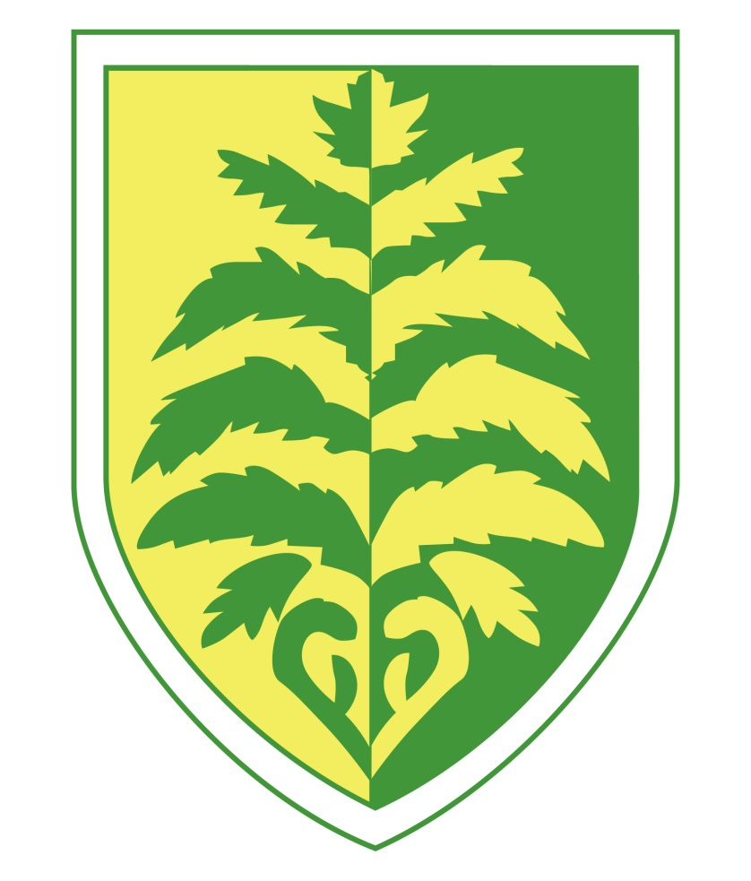

National Curriculum for English

English – Year 3 and Year 4
Reading – word reading
Pupils will be taught to:
- apply their growing knowledge of root words, prefixes and suffixes (etymology and morphology), both to read aloud and to understand the meaning of new words they meet

- read further exception words, noting the unusual correspondences between spelling and sound, and where these occur in the word.

Reading – comprehension
Pupils will be taught to:
-develop positive attitudes to reading and understanding of what they read by:
- listening to and discussing a wide range of fiction, poetry, plays, non-fiction and reference books or textbooks
- reading books that are structured in different ways and reading for a range of purposes
- using dictionaries to check the meaning of words that they have read
- increasing their familiarity with a wide range of books, including fairy stories, myths and legends, and retelling some of these orally
- identifying themes and conventions in a wide range of books
- preparing poems and play scripts to read aloud and to perform, showing understanding through intonation, tone, volume and action
- discussing words and phrases that capture the reader’s interest and imagination
- recognising some different forms of poetry [for example, free verse, narrative poetry]
-understand what they read, in books they can read independently, by:
- checking that the text makes sense to them, discussing their understanding and explaining the meaning of words in context
- asking questions to improve their understanding of a text
- drawing inferences such as inferring characters’ feelings, thoughts and motives from their actions, and justifying inferences with evidence
- predicting what might happen from details stated and implied
- identifying main ideas drawn from more than one paragraph and summarising these
- identifying how language, structure, and presentation contribute to meaning
-retrieve and record information from non-fiction
-participate in discussion about both books that are read to them and those they can read for themselves, taking turns and listening to what others say.

Spelling
Pupils will be taught to:
- use further prefixes and suffixes and understand how to add them
- spell further homophones
- spell words that are often misspelt
- place the possessive apostrophe accurately in words with regular plurals [for example, girls’, boys’] and in words with irregular plurals [for example, children’s]
- use the first two or three letters of a word to check its spelling in a dictionary
- write from memory simple sentences, dictated by the teacher, that include words and punctuation taught so far.

Handwriting
Pupils should be taught to:
- use the diagonal and horizontal strokes that are needed to join letters and understand which letters, when adjacent to one another, are best left unjoined

- increase the legibility, consistency and quality of their handwriting [for example, by ensuring that the downstrokes of letters are parallel and equidistant; that lines of writing are spaced sufficiently so that the ascenders and descenders of letters do not touch].

Writing Composition
Pupils will be taught to:
-plan their writing by:
- discussing writing similar to that which they are planning to write in order to understand and learn from its structure, vocabulary and grammar
- discussing and recording ideas
-draft and write by:
- composing and rehearsing sentences orally (including dialogue), progressively building a varied and rich vocabulary and an increasing range of sentence structures (English Appendix 2)
- organising paragraphs around a theme
- in narratives, creating settings, characters and plot
- in non-narrative material, using simple organisational devices [for example, headings and sub-headings]
-evaluate and edit by:
- assessing the effectiveness of their own and others’ writing and suggesting improvements
- proposing changes to grammar and vocabulary to improve consistency, including the accurate use of pronouns in sentences
- proof-read for spelling and punctuation errors
- read aloud their own writing, to a group or the whole class, using appropriate intonation and controlling the tone and volume so that the meaning is clear.
Vocabulary, grammar and punctuation
Pupils will be taught to:
-develop their understanding of the concepts set out by:
- extending the range of sentences with more than one clause by using a wider range of conjunctions, including when, if, because, although
- using the present perfect form of verbs in contrast to the past tense
- choosing nouns or pronouns appropriately for clarity and cohesion and to avoid repetition
- using conjunctions, adverbs and prepositions to express time and cause
- using fronted adverbials
- learning the grammar for years 3 and 4
-indicate grammatical and other features by:
- using commas after fronted adverbials
- indicating possession by using the possessive apostrophe with plural nouns
- using and punctuating direct speech
-use and understand grammatical terminology accurately and appropriately when discussing their writing and reading.

English – Year 5 and Year 6
Reading – word reading
Pupils will be taught to:
- apply their growing knowledge of root words, prefixes and suffixes (morphology and etymology), both to read aloud and to understand the meaning of new words that they meet.
Reading – Comprehension
Pupils will be taught to:
-maintain positive attitudes to reading and understanding of what they read by:
- continuing to read and discuss an increasingly wide range of fiction, poetry, plays, non-fiction and reference books or textbooks
- reading books that are structured in different ways and reading for a range of purposes
- increasing their familiarity with a wide range of books, including myths, legends and traditional stories, modern fiction, fiction from our literary heritage, and books from other cultures and traditions
- recommending books that they have read to their peers, giving reasons for their choices
- identifying and discussing themes and conventions in and across a wide range of writing
- making comparisons within and across books
- learning a wider range of poetry by heart
- preparing poems and plays to read aloud and to perform, showing understanding through intonation, tone and volume so that the meaning is clear to an audience
-understand what they read by:
- checking that the book makes sense to them, discussing their understanding and exploring the meaning of words in context
- asking questions to improve their understanding
- drawing inferences such as inferring characters’ feelings, thoughts and motives from their actions, and justifying inferences with evidence
- predicting what might happen from details stated and implied
- summarising the main ideas drawn from more than one paragraph, identifying key details that support the main ideas
- identifying how language, structure and presentation contribute to meaning
- discuss and evaluate how authors use language, including figurative language, considering the impact on the reader
- distinguish between statements of fact and opinion
- retrieve, record and present information from non-fiction
- participate in discussions about books that are read to them and those they can read for themselves, building on their own and others’ ideas and challenging views courteously
- explain and discuss their understanding of what they have read, including through formal presentations and debates, maintaining a focus on the topic and using notes where necessary
- provide reasoned justifications for their views.

Spelling
Pupils will be taught to:
- use further prefixes and suffixes and understand the guidance for adding them
- spell some words with ‘silent’ letters [for example, knight, psalm, solemn]
- continue to distinguish between homophones and other words which are often confused
- use knowledge of morphology and etymology in spelling and understand that the spelling of some words needs to be learnt specifically
- use dictionaries to check the spelling and meaning of words
- use the first three or four letters of a word to check spelling, meaning or both of these in a dictionary
- use a thesaurus
Handwriting and presentation
Pupils will be taught to:
- write legibly, fluently and with increasing speed by:
- choosing which shape of a letter to use when given choices and deciding whether or not to join specific letters
- choosing the writing implement that is best suited for a task.
Writing composition
Pupils will be taught to:
-plan their writing by:
- identifying the audience for and purpose of the writing, selecting the appropriate form and using other similar writing as models for their own
- noting and developing initial ideas, drawing on reading and research where necessary
- in writing narratives, considering how authors have developed characters and settings in what pupils have read, listened to or seen performed
-draft and write by:
- selecting appropriate grammar and vocabulary, understanding how such choices can change and enhance meaning
- in narratives, describing settings, characters and atmosphere and integrating dialogue to convey character and advance the action
- précising longer passages
- using a wide range of devices to build cohesion within and across paragraphs
- using further organisational and presentational devices to structure text and to guide the reader [for example, headings, bullet points, underlining]
-evaluate and edit by:
- assessing the effectiveness of their own and others’ writing
- proposing changes to vocabulary, grammar and punctuation to enhance effects and clarify meaning
- ensuring the consistent and correct use of tense throughout a piece of writing
- ensuring correct subject and verb agreement when using singular and plural, distinguishing between the language of speech and writing and choosing the appropriate register
- proof-read for spelling and punctuation errors
- perform their own compositions, using appropriate intonation, volume, and movement so that meaning is clear.
Writing – vocabulary, grammar and punctuation
Pupils will be taught to:
-develop their understanding of the concepts by:
- recognising vocabulary and structures that are appropriate for formal speech and writing, including subjunctive forms
- using passive verbs to affect the presentation of information in a sentence
- using the perfect form of verbs to mark relationships of time and cause
- using expanded noun phrases to convey complicated information concisely
- using modal verbs or adverbs to indicate degrees of possibility
- using relative clauses beginning with who, which, where, when, whose, that or with an implied (i.e. omitted) relative pronoun
- learning the grammar for years 5 and 6
-indicate grammatical and other features by:
- using commas to clarify meaning or avoid ambiguity in writing
- using hyphens to avoid ambiguity
- using brackets, dashes or commas to indicate parenthesis
- using semi-colons, colons or dashes to mark boundaries between independent clauses
- using a colon to introduce a list
- punctuating bullet points consistently
-use and understand the grammatical terminology accurately and appropriately in discussing their writing and reading.

