Brackenwood Junior School

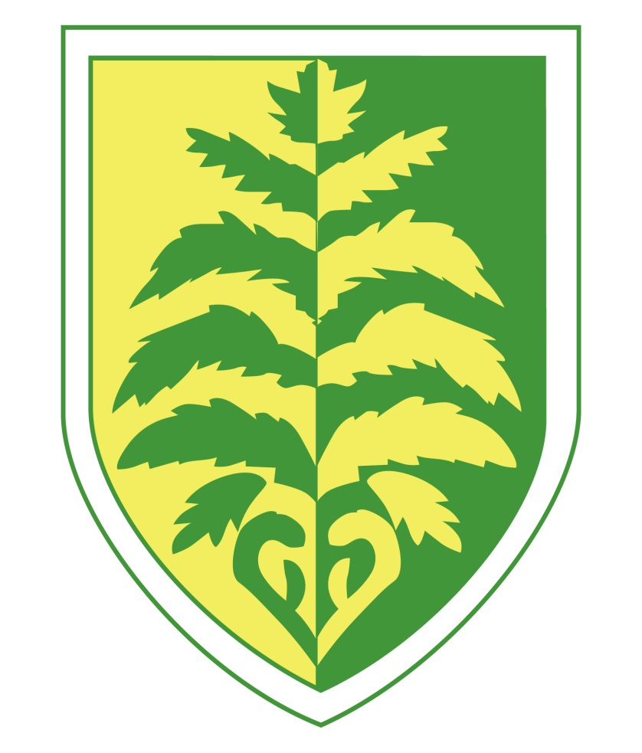

National Curriculum for Mathematics

Mathematics – Year 3

Number – Number and Place value

Pupils will be taught to:

* count from 0 in multiples of 4, 8, 50 and 100; find 10 or 100 more or less than a given number
* recognise the place value of each digit in a three-digit number (hundreds, tens, ones)
* compare and order numbers up to 1000
* identify, represent and estimate numbers using different representations
* read and write numbers up to 1000 in numerals and in words
* solve number problems and practical problems involving these ideas.

Number – Addition and Subtraction

Pupils will be taught to:

* add and subtract numbers mentally, including:
* a three-digit number and ones
* a three-digit number and tens
* a three-digit number and hundreds
* add and subtract numbers with up to three digits, using formal written methods of columnar addition and subtraction
* estimate the answer to a calculation and use inverse operations to check answers
* solve problems, including missing number problems, using number facts, place value, and more complex addition and subtraction.

Number – Multiplication and Division

Pupils should be taught to:

* recall and use multiplication and division facts for the 3, 4 and 8 multiplication tables
* write and calculate mathematical statements for multiplication and division using the multiplication tables that they know, including for two-digit numbers times one-digit numbers, using mental and progressing to formal written methods
* solve problems, including missing number problems, involving multiplication and division, including positive integer scaling problems and correspondence problems in which n objects are connected to m objects.

Number – Fractions

Pupils will be taught to:

* count up and down in tenths; recognise that tenths arise from dividing an object into 10 equal parts and in dividing one-digit numbers or quantities by 10
* recognise, find and write fractions of a discrete set of objects: unit fractions and non-unit fractions with small denominators
* recognise and use fractions as numbers: unit fractions and non-unit fractions with small denominators
* recognise and show, using diagrams, equivalent fractions with small denominators
* add and subtract fractions with the same denominator within one whole [for example,  +  = ]
* compare and order unit fractions, and fractions with the same denominators
* solve problems that involve all of the above.

Measurement

Pupils will be taught to:

* measure, compare, add and subtract: lengths (m/cm/mm); mass (kg/g); volume/capacity (l/ml)
* measure the perimeter of simple 2-D shapes
* add and subtract amounts of money to give change, using both £ and p in practical contexts
* tell and write the time from an analogue clock, including using Roman numerals from I to XII, and 12-hour and 24-hour clocks
* estimate and read time with increasing accuracy to the nearest minute; record and compare time in terms of seconds, minutes and hours; use vocabulary such as o’clock, a.m./p.m., morning, afternoon, noon and midnight
* know the number of seconds in a minute and the number of days in each month, year and leap year
* compare durations of events [for example to calculate the time taken by particular events or tasks].

Geometry – Properties of Shapes

Pupils will be taught to:

* draw 2-D shapes and make 3-D shapes using modelling materials; recognise 3-D shapes in different orientations and describe them
* recognise angles as a property of shape or a description of a turn
* identify right angles, recognise that two right angles make a half-turn, three make three quarters of a turn and four a complete turn; identify whether angles are greater than or less than a right angle
* identify horizontal and vertical lines and pairs of perpendicular and parallel lines.

Statistics

Pupils will be taught to:

* interpret and present data using bar charts, pictograms and tables
* solve one-step and two-step questions [for example, ‘How many more?’ and ‘How many fewer?’] using information presented in scaled bar charts and pictograms and tables.

Mathematics – Year 4

Number – Number and Place value

Pupils will be taught to:

* count in multiples of 6, 7, 9, 25 and 1000
* find 1000 more or less than a given number
* count backwards through zero to include negative numbers
* recognise the place value of each digit in a four-digit number (thousands, hundreds, tens, and ones)
* order and compare numbers beyond 1000
* identify, represent and estimate numbers using different representations
* round any number to the nearest 10, 100 or 1000
* solve number and practical problems that involve all of the above and with increasingly large positive numbers
* read Roman numerals to 100 (I to C) and know that over time, the numeral system changed to include the concept of zero and place value.

Number – Addition and Subtraction

Pupils will be taught to:

* add and subtract numbers with up to 4 digits using the formal written methods of columnar addition and subtraction where appropriate
* estimate and use inverse operations to check answers to a calculation
* solve addition and subtraction two-step problems in contexts, deciding which operations and methods to use and why

Number – Multiplication and Division

Pupils will be taught to:

* recall multiplication and division facts for multiplication tables up to 12 × 12
* use place value, known and derived facts to multiply and divide mentally, including: multiplying by 0 and 1; dividing by 1; multiplying together three numbers
* recognise and use factor pairs and commutativity in mental calculations
* multiply two-digit and three-digit numbers by a one-digit number using formal written layout

solve problems involving multiplying and adding, including using the distributive law to multiply two digit numbers by one digit, integer scaling problems and harder correspondence problems such as n objects are connected to m objects.

Number – Fractions (including decimals)

Pupils will be taught to:

* recognise and show, using diagrams, families of common equivalent fractions
* count up and down in hundredths; recognise that hundredths arise when dividing an object by one hundred and dividing tenths by ten.
* solve problems involving increasingly harder fractions to calculate quantities, and fractions to divide quantities, including non-unit fractions where the answer is a whole number
* add and subtract fractions with the same denominator
* recognise and write decimal equivalents of any number of tenths or hundredths
* recognise and write decimal equivalents to , , 
* find the effect of dividing a one- or two-digit number by 10 and 100, identifying the value of the digits in the answer as ones, tenths and hundredths
* round decimals with one decimal place to the nearest whole number
* compare numbers with the same number of decimal places up to two decimal places

solve simple measure and money problems involving fractions and decimals to two decimal places.

Measurement

Pupils will be taught to:

* Convert between different units of measure [for example, kilometre to metre; hour to minute]
* measure and calculate the perimeter of a rectilinear figure (including squares) in centimetres and metres
* find the area of rectilinear shapes by counting squares
* estimate, compare and calculate different measures, including money in pounds and pence

Geometry – properties of shapes

Pupils will be taught to:

* compare and classify geometric shapes, including quadrilaterals and triangles**,** based on their properties and sizes
* identify acute and obtuse angles and compare and order angles up to two right angles by size
* identify lines of symmetry in 2-D shapes presented in different orientations
* complete a simple symmetric figure with respect to a specific line of symmetry.

Geometry – position and direction

Pupils will be taught to:

* describe positions on a 2-D grid as coordinates in the first quadrant
* describe movements between positions as translations of a given unit to the left/right and up/down
* plot specified points and draw sides to complete a given polygon.

Statistics

Pupils will be taught to:

* interpret and present discrete and continuous data using appropriate graphical methods, including bar charts and time graphs.
* solve comparison, sum and difference problems using information presented in bar charts, pictograms, tables and other graphs.

Mathematics – Year 5

Number – Number and Place Value

Pupils will be taught to:

* read, write, order and compare numbers to at least 1 000 000 and determine the value of each digit
* count forwards or backwards in steps of powers of 10 for any given number up to 1 000 000
* interpret negative numbers in context, count forwards and backwards with positive and negative whole numbers, including through zero
* round any number up to 1 000 000 to the nearest 10, 100, 1000, 10 000 and 100 000
* solve number problems and practical problems that involve all of the above
* read Roman numerals to 1000 (M) and recognise years written in Roman numerals.

Number – addition and subtraction

Pupils will be taught to:

* add and subtract whole numbers with more than 4 digits, including using formal written methods (columnar addition and subtraction)
* add and subtract numbers mentally with increasingly large numbers
* use rounding to check answers to calculations and determine, in the context of a problem, levels of accuracy
* solve addition and subtraction multi-step problems in contexts, deciding which operations and methods to use and why.

Number – multiplication and division

Pupils will be taught to:

* identify multiples and factors, including finding all factor pairs of a number, and common factors of two numbers
* know and use the vocabulary of prime numbers, prime factors and composite (non-prime) numbers
* establish whether a number up to 100 is prime and recall prime numbers up to 19
* multiply numbers up to 4 digits by a one- or two-digit number using a formal written method, including long multiplication for two-digit numbers
* multiply and divide numbers mentally drawing upon known facts
* divide numbers up to 4 digits by a one-digit number using the formal written method of short division and interpret remainders appropriately for the context
* multiply and divide whole numbers and those involving decimals by 10, 100 and 1000
* recognise and use square numbers and cube numbers, and the notation for squared (2) and cubed (3)
* solve problems involving multiplication and division including using their knowledge of factors and multiples, squares and cubes
* solve problems involving addition, subtraction, multiplication and division and a combination of these, including understanding the meaning of the equals sign
* solve problems involving multiplication and division, including scaling by simple fractions and problems involving simple rates.

Number – fractions (including decimals and percentages)

Pupils will be taught to:

* compare and order fractions whose denominators are all multiples of the same number
* identify, name and write equivalent fractions of a given fraction, represented visually, including tenths and hundredths
* recognise mixed numbers and improper fractions and convert from one form to the other and write mathematical statements > 1 as a mixed number [for example,  +  =  = 1]
* add and subtract fractions with the same denominator and denominators that are multiples of the same number
* multiply proper fractions and mixed numbers by whole numbers, supported by materials and diagrams
* read and write decimal numbers as fractions [for example, 0.71 = ]
* recognise and use thousandths and relate them to tenths, hundredths and decimal equivalents
* round decimals with two decimal places to the nearest whole number and to one decimal place
* read, write, order and compare numbers with up to three decimal places
* solve problems involving number up to three decimal places
* recognise the per cent symbol (%) and understand that per cent relates to ‘number of parts per hundred’, and write percentages as a fraction with denominator 100, and as a decimal
* solve problems which require knowing percentage and decimal equivalents of , , , ,  and those fractions with a denominator of a multiple of 10 or 25.

Measurement

Pupils will be taught to:

* convert between different units of metric measure (for example, kilometre and metre; centimetre and metre; centimetre and millimetre; gram and kilogram; litre and millilitre)
* understand and use approximate equivalences between metric units and common imperial units such as inches, pounds and pints
* measure and calculate the perimeter of composite rectilinear shapes in centimetres and metres
* calculate and compare the area of rectangles (including squares), and including using standard units, square centimetres (cm2) and square metres (m2) and estimate the area of irregular shapes
* estimate volume [for example, using 1 cm3 blocks to build cuboids (including cubes)] and capacity [for example, using water]
* solve problems involving converting between units of time
* use all four operations to solve problems involving measure [for example, length, mass, volume, money] using decimal notation, including scaling.

Geometry – properties of shapes

Pupils will be taught to:

* identify 3-D shapes, including cubes and other cuboids, from 2-D representations
* know angles are measured in degrees: estimate and compare acute, obtuse and reflex angles
* draw given angles, and measure them in degrees (o)
* identify:
* angles at a point and one whole turn (total 360o)
* angles at a point on a straight line and  a turn (total 180o)
* other multiples of 90o
* use the properties of rectangles to deduce related facts and find missing lengths and angles
* distinguish between regular and irregular polygons based on reasoning about equal sides and angles.

Geometry – position and direction

Pupils will be taught to:

* identify, describe and represent the position of a shape following a reflection or translation, using the appropriate language, and know that the shape has not changed.

Statistics

Pupils will be taught to:

* solve comparison, sum and difference problems using information presented in a line graph
* complete, read and interpret information in tables, including timetables.

Mathematics – Year 6

Number – number and place value

Pupils will be taught to:

* read, write, order and compare numbers up to 10 000 000 and determine the value of each digit
* round any whole number to a required degree of accuracy
* use negative numbers in context, and calculate intervals across zero
* solve number and practical problems that involve all of the above.

Number – addition, subtraction, multiplication & division

Pupils will be taught to:

* multiply multi-digit numbers up to 4 digits by a two-digit whole number using the formal written method of long multiplication
* divide numbers up to 4 digits by a two-digit whole number using the formal written method of long division, and interpret remainders as whole number remainders, fractions, or by rounding, as appropriate for the context
* divide numbers up to 4 digits by a two-digit number using the formal written method of short division where appropriate, interpreting remainders according to the context
* perform mental calculations, including with mixed operations and large numbers
* identify common factors, common multiples and prime numbers
* use their knowledge of the order of operations to carry out calculations involving the four operations
* solve addition and subtraction multi-step problems in contexts, deciding which operations and methods to use and why
* solve problems involving addition, subtraction, multiplication and division
* use estimation to check answers to calculations and determine, in the context of a problem, an appropriate degree of accuracy.

Number – fractions (including decimals and percentages)

Pupils will be taught to:

* use common factors to simplify fractions; use common multiples to express fractions in the same denomination
* compare and order fractions, including fractions > 1
* add and subtract fractions with different denominators and mixed numbers, using the concept of equivalent fractions
* multiply simple pairs of proper fractions, writing the answer in its simplest form [for example,  × = ]
* divide proper fractions by whole numbers [for example,  ÷ 2 = ]
* associate a fraction with division and calculate decimal fraction equivalents [for example, 0.375] for a simple fraction [for example, ]
* identify the value of each digit in numbers given to three decimal places and multiply and divide numbers by 10, 100 and 1000 giving answers up to three decimal places
* multiply one-digit numbers with up to two decimal places by whole numbers
* use written division methods in cases where the answer has up to two decimal places
* solve problems which require answers to be rounded to specified degrees of accuracy
* recall and use equivalences between simple fractions, decimals and percentages, including in different contexts.

Ratio and proportion

Pupils will be taught to:

* solve problems involving the relative sizes of two quantities where missing values can be found by using integer multiplication and division facts
* solve problems involving the calculation of percentages [for example, of measures, and such as 15% of 360] and the use of percentages for comparison
* solve problems involving similar shapes where the scale factor is known or can be found
* solve problems involving unequal sharing and grouping using knowledge of fractions and multiples.

Algebra

Pupils will be taught to:

* use simple formulae
* generate and describe linear number sequences
* express missing number problems algebraically
* find pairs of numbers that satisfy an equation with two unknowns
* enumerate possibilities of combinations of two variables.

Measurement

Pupils will be taught to:

* solve problems involving the calculation and conversion of units of measure, using decimal notation up to three decimal places where appropriate
* use, read, write and convert between standard units, converting measurements of length, mass, volume and time from a smaller unit of measure to a larger unit, and vice versa, using decimal notation to up to three decimal places
* convert between miles and kilometres
* recognise that shapes with the same areas can have different perimeters and vice versa
* recognise when it is possible to use formulae for area and volume of shapes
* calculate the area of parallelograms and triangles
* calculate, estimate and compare volume of cubes and cuboids using standard units, including cubic centimetres (cm3) and cubic metres (m3), and extending to other units [for example, mm3 and km3].

Geometry – properties of shapes

Pupils will be taught to:

* draw 2-D shapes using given dimensions and angles
* recognise, describe and build simple 3-D shapes, including making nets
* compare and classify geometric shapes based on their properties and sizes and find unknown angles in any triangles, quadrilaterals, and regular polygons
* illustrate and name parts of circles, including radius, diameter and circumference and know that the diameter is twice the radius
* recognise angles where they meet at a point, are on a straight line, or are vertically opposite, and find missing angles.

Geometry – position and direction

Pupils will be taught to:

* describe positions on the full coordinate grid (all four quadrants)
* draw and translate simple shapes on the coordinate plane, and reflect them in the axes.

Statistics

Pupils will be taught to:

* interpret and construct pie charts and line graphs and use these to solve problems
* calculate and interpret the mean as an average.