Brackenwood Junior School
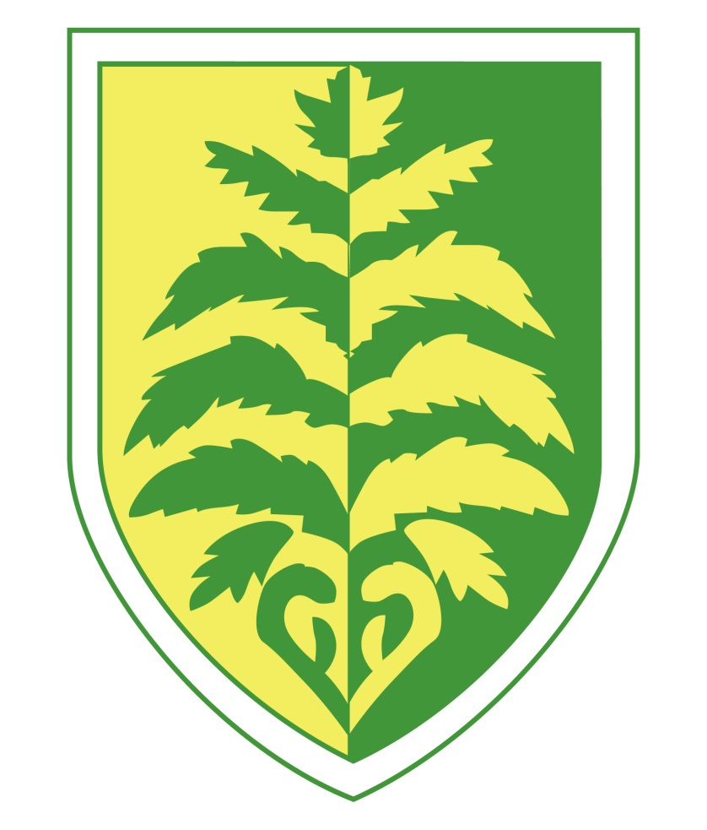

National Curriculum for Non-Core Subjects

Art and design: Years 3-6
Pupils will be taught to develop their techniques, including their control and their use of materials, with creativity, experimentation and an increasing awareness of different kinds of art, craft and design.
Pupils will be taught:
- to create sketch books to record their observations and use them to review and revisit ideas
- to improve their mastery of art and design techniques, including drawing, painting and sculpture with a range of materials [for example, pencil, charcoal, paint, clay]
- about great artists, architects and designers in history.

Computing: Years 3-6
Pupils will be taught to:
- design, write and debug programs that accomplish specific goals, including controlling or simulating physical systems; solve problems by decomposing them into smaller parts
- use sequence, selection, and repetition in programs; work with variables and various forms of input and output
- use logical reasoning to explain how some simple algorithms work and to detect and correct errors in algorithms and programs
- understand computer networks including the internet; how they can provide multiple services, such as the world wide web; and the opportunities they offer for communication and collaboration
- use search technologies effectively, appreciate how results are selected and ranked, and be discerning in evaluating digital content
- select, use and combine a variety of software (including internet services) on a range of digital devices to design and create a range of programs, systems and content that accomplish given goals, including collecting, analysing, evaluating and presenting data and information
- use technology safely, respectfully and responsibly; recognise acceptable/unacceptable behaviour; identify a range of ways to report concerns about content and contact.

Design and technology: Years 3-6
Through a variety of creative and practical activities, pupils should be taught the knowledge, understanding and skills needed to engage in an iterative process of designing and making. They should work in a range of relevant contexts [for example, the home, school, leisure, culture, enterprise, industry and the wider environment].
Pupils will be taught to:

Design
- use research and develop design criteria to inform the design of innovative, functional, appealing products that are fit for purpose, aimed at particular individuals or groups
- generate, develop, model and communicate their ideas through discussion, annotated sketches, cross-sectional and exploded diagrams, prototypes, pattern pieces and computer-aided design
Make
- select from and use a wider range of tools and equipment to perform practical tasks [for example, cutting, shaping, joining and finishing], accurately
- select from and use a wider range of materials and components, including construction materials, textiles and ingredients, according to their functional properties and aesthetic qualities
Evaluate
- investigate and analyse a range of existing products
- evaluate their ideas and products against their own design criteria and consider the views of others to improve their work
- understand how key events and individuals in design and technology have helped shape the world
Technical knowledge
- apply their understanding of how to strengthen, stiffen and reinforce more complex structures
- understand and use mechanical systems in their products [for example, gears, pulleys, cams, levers and linkages]
- understand and use electrical systems in their products [for example, series circuits incorporating switches, bulbs, buzzers and motors]
- apply their understanding of computing to program, monitor and control their products.
Cooking and nutrition
- understand and apply the principles of a healthy and varied diet
- prepare and cook a variety of predominantly savoury dishes using a range of cooking techniques
- understand seasonality, and know where and how a variety of ingredients are grown, reared, caught and processed.

Geography Years 3-6
Pupils should extend their knowledge and understanding beyond the local area to include the United Kingdom and Europe, North and South America. This will include the location and characteristics of a range of the world’s most significant human and physical features. They should develop their use of geographical knowledge, understanding and skills to enhance their locational and place knowledge.
Pupils will be taught to:

Locational knowledge
- locate the world’s countries, using maps to focus on Europe (including the location of Russia) and North and South America, concentrating on their environmental regions, key physical and human characteristics, countries, and major cities
- name and locate counties and cities of the United Kingdom, geographical regions and their identifying human and physical characteristics, key topographical features (including hills, mountains, coasts and rivers), and land-use patterns; and understand how some of these aspects have changed over time
- identify the position and significance of latitude, longitude, Equator, Northern Hemisphere, Southern Hemisphere, the Tropics of Cancer and Capricorn, Arctic and Antarctic Circle, the Prime/Greenwich Meridian and time zones (including day and night)
Place knowledge
- understand geographical similarities and differences through the study of human and physical geography of a region of the United Kingdom, a region in a European country, and a region within North or South America
Human and physical geography
- describe and understand key aspects of:
- physical geography, including: climate zones, biomes and vegetation belts, rivers, mountains, volcanoes and earthquakes, and the water cycle
- human geography, including: types of settlement and land use, economic activity including trade links, and the distribution of natural resources including energy, food, minerals and water

Geographical skills and fieldwork
- use maps, atlases, globes and digital/computer mapping to locate countries and describe features studied
- use the eight points of a compass, four and six-figure grid references, symbols and key (including the use of Ordnance Survey maps) to build their knowledge of the United Kingdom and the wider world
- use fieldwork to observe, measure, record and present the human and physical features in the local area using a range of methods, including sketch maps, plans and graphs, and digital technologies.

History: Years 3-6
Pupils should continue to develop a chronologically secure knowledge and understanding of British, local and world history, establishing clear narratives within and across the periods they study. They should note connections, contrasts and trends over time and develop the appropriate use of historical terms. They should regularly address and sometimes devise historically valid questions about change, cause, similarity and difference, and significance. They should construct informed responses that involve thoughtful selection and organisation of relevant historical information. They should understand how our knowledge of the past is constructed from a range of sources.
In planning to ensure the progression described above through teaching the British, local and world history outlined below, teachers should combine overview and depth studies to help pupils understand both the long arc of development and the complexity of specific aspects of the content.
Pupils should be taught about:
- changes in Britain from the Stone Age to the Iron Age
- the Roman Empire and its impact on Britain
- Britain’s settlement by Anglo-Saxons and Scots
- the Viking and Anglo-Saxon struggle for the Kingdom of England to the time of Edward the Confessor
- a local history study
- a study of an aspect or theme in British history that extends pupils’ chronological knowledge beyond 1066
- the achievements of the earliest civilizations – an overview of where and when the first civilizations appeared and a depth study of one of the following: Ancient Sumer; The Indus Valley; Ancient Egypt; The Shang Dynasty of Ancient China
- Ancient Greece – a study of Greek life and achievements and their influence on the western world
- a non-European society that provides contrasts with British history – one study chosen from: early Islamic civilization, including a study of Baghdad c. AD 900; Mayan civilization c. AD 900; Benin (West Africa) c. AD 900-1300.

Languages: Years 3-6
Teaching may be of any modern or ancient foreign language and should focus on enabling pupils to make substantial progress in one language. The teaching should provide an appropriate balance of spoken and written language and should lay the foundations for further foreign language teaching at key stage 3. It should enable pupils to understand and communicate ideas, facts and feelings in speech and writing, focused on familiar and routine matters, using their knowledge of phonology, grammatical structures and vocabulary.
The focus of study in modern languages will be on practical communication. If an ancient language is chosen the focus will be to provide a linguistic foundation for reading comprehension and an appreciation of classical civilisation. Pupils studying ancient languages may take part in simple oral exchanges, while discussion of what they read will be conducted in English. A linguistic foundation in ancient languages may support the study of modern languages at key stage 3.
Pupils will be taught to:
- listen attentively to spoken language and show understanding by joining in and responding
- explore the patterns and sounds of language through songs and rhymes and link the spelling, sound and meaning of words
- engage in conversations; ask and answer questions; express opinions and respond to those of others; seek clarification and help
- speak in sentences, using familiar vocabulary, phrases and basic language structures
- develop accurate pronunciation and intonation so that others understand when they are reading aloud or using familiar words and phrases
- present ideas and information orally to a range of audiences
- read carefully and show understanding of words, phrases and simple writing
- appreciate stories, songs, poems and rhymes in the language
- broaden their vocabulary and develop their ability to understand new words that are introduced into familiar written material, including through using a dictionary
- write phrases from memory, and adapt these to create new sentences, to express ideas clearly
- describe people, places, things and actions orally and in writing
- understand basic grammar appropriate to the language being studied, including (where relevant): feminine, masculine and neuter forms and the conjugation of high-frequency verbs; key features and patterns of the language; how to apply these, for instance, to build sentences; and how these differ from or are similar to English.

Physical education: Years 3-6

Pupils should continue to apply and develop a broader range of skills, learning how to use them in different ways and to link them to make actions and sequences of movement. They should enjoy communicating, collaborating and competing with each other. They should develop an understanding of how to improve in different physical activities and sports and learn how to evaluate and recognise their own success.
Pupils should be taught to:
- use running, jumping, throwing and catching in isolation and in combination
- play competitive games, modified where appropriate [for example, badminton, basketball, cricket, football, hockey, netball, rounders and tennis], and apply basic principles suitable for attacking and defending
- develop flexibility, strength, technique, control and balance [for example, through athletics and gymnastics]
- perform dances using a range of movement patterns
- take part in outdoor and adventurous activity challenges both individually and within a team
- compare their performances with previous ones and demonstrate improvement to achieve their personal best.
Swimming and water safety
All schools must provide swimming instruction either in key stage 1 or key stage 2.
In particular, pupils should be taught to:
- swim competently, confidently and proficiently over a distance of at least 25 metres
- use a range of strokes effectively [for example, front crawl, backstroke and breaststroke]
- perform safe self-rescue in different water-based situations.

Music Years 3-6
Pupils should be taught to sing and play musically with increasing confidence and control. They should develop an understanding of musical composition, organising and manipulating ideas within musical structures and reproducing sounds from aural memory.
Pupils should be taught to:
- play and perform in solo and ensemble contexts, using their voices and playing musical instruments with increasing accuracy, fluency, control and expression
- improvise and compose music for a range of purposes using the inter-related dimensions of music
- listen with attention to detail and recall sounds with increasing aural memory
- use and understand staff and other musical notations
- appreciate and understand a wide range of high-quality live and recorded music drawn from different traditions and from great composers and musicians
- develop an understanding of the history of music.

